
AdvanceD Point of Sale
Point of Sale system (POS)
SQL server Database configuration guide
October 20, 2017
DynamicSoft
http://www.codecanyon.net/user/dynamicsoft
Before Start check this video - > How to setup APOS using SQL server database - 39:57
If you don't have SQL server 2008. Please follow
Step-1.
Please Download SQL server 2008.
http://www.microsoft.com/en-us/download/details.aspx?id=1695
Step-2
and Follow how to install it on your machine.
https://www.youtube.com/watch?v=_PJXFcRPKFc SQL 2008
https://www.youtube.com/watch?v=8WAdeP5YREo SQL 2008 R2
-----------------------------------------------------------------------------------
How to Setup SQL Database script into SQL Server 2008
Requirement _____________________________________________________________
- Visual studio 2010 – up-to target Framework="4.0"
- MSSQL server 2008 – up-to
Step: 1
How to Setup Database Full youtube Video
- Open SQL server 2008
- Create a New Database in your SQL Server 2008 DB Name is = “APOSDB”
- Click on DB select - > New Query
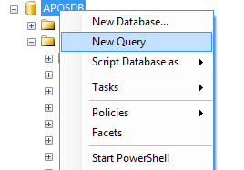

[Youtube] How to import sql database script

- Copy all text from 'APOSDB.sql' file with note pad Copy all code and paste into New Query Panel. and Press F5 or Execute
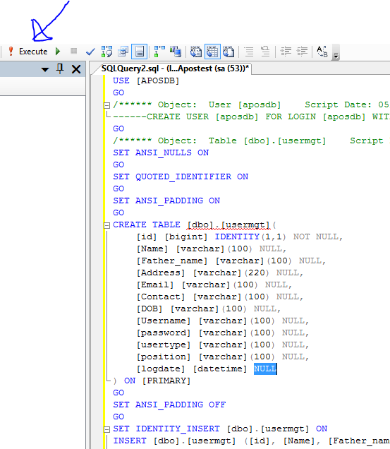

Open project From POS_SQLite folder with VS 2010 -- See How to open
- Delete Current DataAccess.cs file from solution explorer

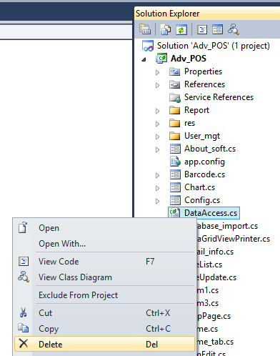

- and Copy "DataAccess_MSSQLServer.cs" file from [POS_6_1_SQL] folder then paste into solution explorer Adv_POS project
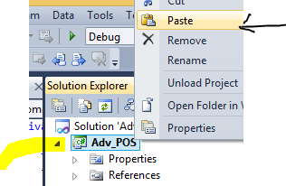
- Rename it to "DataAccess.cs"
Open "DataAccess.cs" file and change your DB source , Database name , User ID, Password
static string _ConnectionString = "Data Source=(local);Initial Catalog=APOSDB; User ID=sauserid;Password=sapass123!";
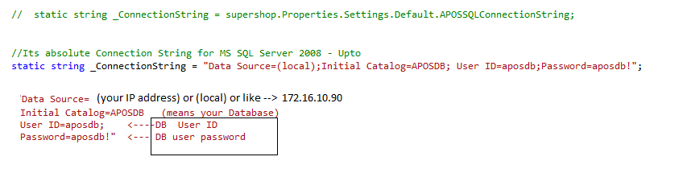
If your MSSQL server have window authentication (MSSQL server 2008 open without Password) please try anyone connection String

static string _ConnectionString = "Data Source=(local); Initial Catalog=APOSDB; ";
OR
static string _ConnectionString = "Data Source=(local); Initial Catalog=APOSDB; Integrated Security=True";
OR
static string _ConnectionString = "Data Source=(local); Initial Catalog=APOSDB; Integrated Security= SSPI ";
OR
static string _ConnectionString = "Data Source=(local); Initial Catalog=APOSDB; Integrated Security=True”; providerName=”System.Data.SqlClient";

- Install ReportViewer.exe from 1. Support_files folder and Install Font UPC-A.ttf from Font- Barcode folder
- Build and Run

How to switch MSSQL server to --> SQLite server
- Delete Current DataAccess.cs file from solution explorer
- and Copy "DataAccess_SQLiteEdition.cs" file then paste into solution explorer Adv_POS project
- Install ReportViewer.exe from 1. Support_files folder (One time if installed plz avoid it)
- Install Font UPC-A.ttf from Font- Barcode folder (One time if installed plz avoid it)
- Build and Run or Press F5

Optional Setup
How to Automatically Open Your Cash Drawer
https://www.youtube.com/watch?v=ECid5KGzuzw

Pole device or Customer Display Configuration
Step1: Open SalesRegister/SalesRegister.cs file with Visual studio 2010
// Add below code after line 558 or UnComment Existing code -- find in vatcal() method line 535 ///////Pole shows Price value | if you have pole device please UnComment below code
SerialPort sp = new SerialPort();
sp.PortName = "COM1"; ////Insert your pole Device Port Name E.g. COM4 -- you can find from pole device manual
sp.BaudRate = 9600; // Pole Baud Rate
sp.Parity = Parity.None;
sp.DataBits = 8; // Data Bits
sp.StopBits = StopBits.One;
sp.Open();
sp.WriteLine(lblTotalPayable.Text);
sp.Close();
sp.Dispose();
sp = null;
How to make installer from source code
Step 1: Please create a new project. (Do not create installer file/project in same project.)
Our Official Video tutorial
https://www.youtube.com/watch?v=4ca8HPnY8hE

User manual – Developers Edition
https://www.youtube.com/watch?v=g91NRvQBRms

Please don’t forget to Rate us http://codecanyon.net/downloads

DynamicSoft

